Activity 3.4 Linear Dimensions

Purpose
If you were given the responsibility of going to a store and purchasing a throw rug that had to fit within a room in your home, how would you communicate the shape and size of the room to the salesperson?

Given the sketching skills that you’ve developed, you would probably sketch a top view of the room on a piece of paper. This would be useful, but a sketch alone only communicates shape information.

A shape has a size that must be communicated in order to make intelligent design decisions. Information about an object’s size must be conveyed using dimensions. In manufacturing, a part must be dimensioned fully and correctly and to the proper precision. Otherwise, the part may not function properly or may not fit into an assembly as intended. Dimensioning errors can lead to a delay in production time, increased design and manufacturing costs, and a potentially unsafe product.

In this activity, you will apply your knowledge of dimensioning to identify dimensioning errors and provide missing dimensions on multi-view drawings. You will also fully dimension multi-view sketches according to dimensioning guidelines.

Equipment
Number 2 pencil with eraser
Engineer’s notebook
Inch scale or ruler

Procedure
Identify dimensioning errors based on the Dimensioning Guidelines. Circle each error and place a letter, A through P, next to each error on the drawing. In the space provided below each drawing, next to the appropriate letter, give the reason for each correction and cite the dimensioning guideline that is misapplied.

1. Multi-view Drawing #1
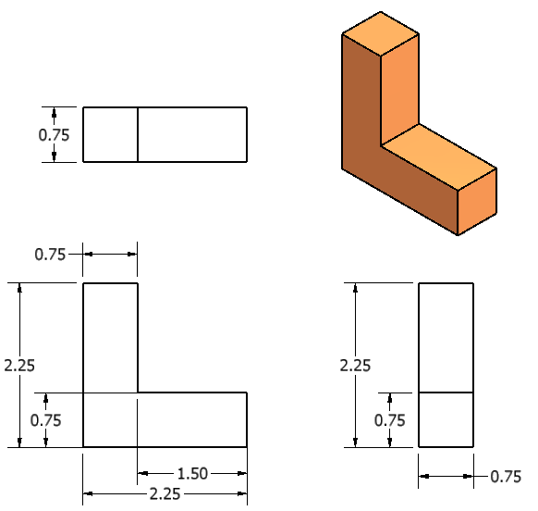
d
c
b
a

 | Dim.  Guide | Reason |  | Dim. Guide. | Reason
 | 4a  7 | Double-dimension;  wrong side |  | 4a | Double-dimension
 | 4a | Double-Dimension |  | 10 | Not needed

2. Multi-view Drawing #2

f
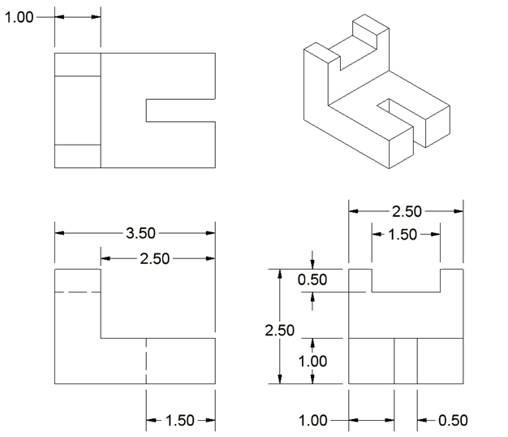
h
g
e

 | Dim.  Guide | Reason |  | Dim. Guide | Reason
 | 8 | Measuring hidden lines. |  | 7 | Wrong view.
 | 7 | Wrong view. |  | 7 | Wrong view.

- Multi-view Drawing #3
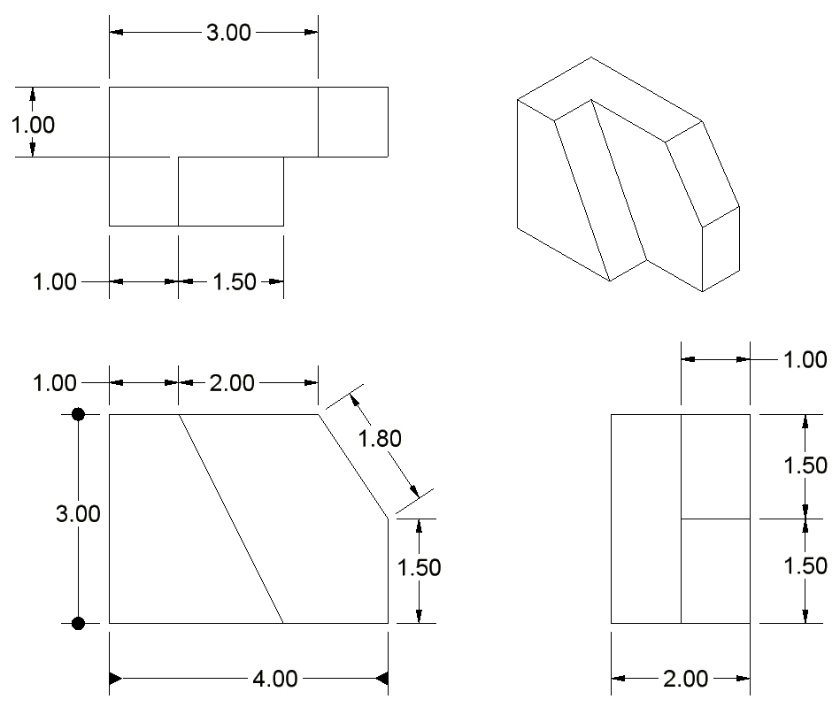
M
N
R
Q
P
O
L
K
J
I
 | Dim.  Guide | Reason |  | Dim. Guide | Reason
 | 4a | Double-Dimension |  | 13 | Needs arrows
 | 13 | Needs arrows |  | 9 | Not needed
 | 4a | Double-Dimension |  | 2a | Needs to be further away.
 | 9 | Not Needed |  | 4a | Double-Dimension
 | 9 | Not needed |  | 2a | Needs to be further away.
- Multi-view Drawing #4
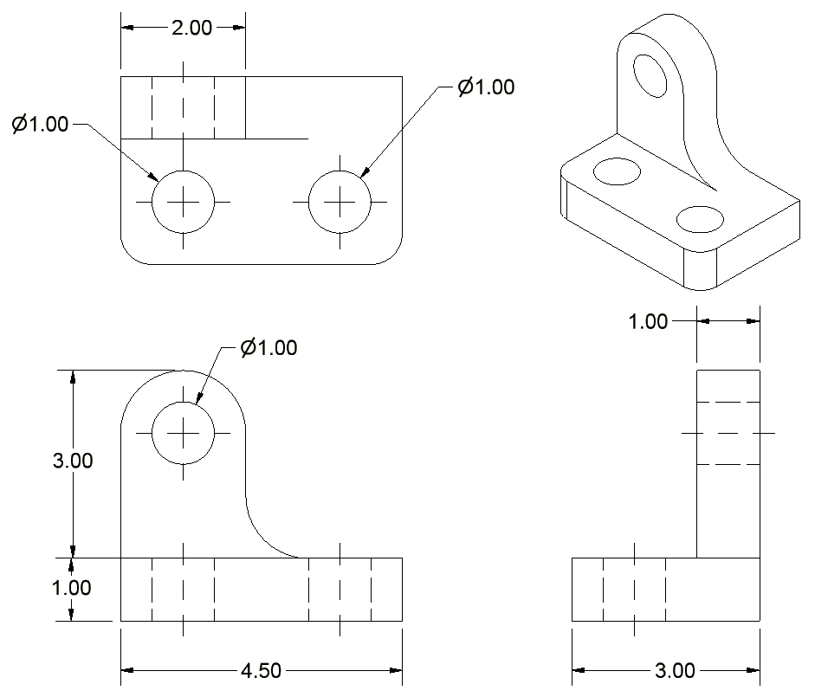
V
U
T
S
 | Dim.  Guide | Reason |  | Dim. Guide | Reason
 | 3a | Need dimension |  | 3a | Need dimension
 | 3a | Need dimension |  | 2a | Needs to be further away

- Sketch an isometric view of the object. Then dimension the orthographic projections. Line spacing on the grid equals 0.125 in.
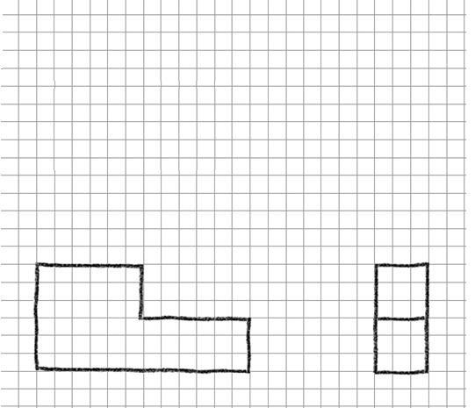
0.75
1.50
0.75
3.00
1.50

- Sketch an isometric pictorial of the object. Then dimension the orthographic projections Line spacing on the grid equals 4 mm.
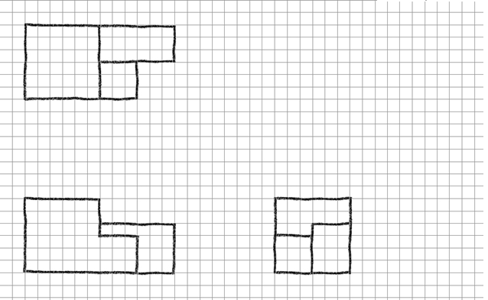
16.00
12.00
24.00
24.00
24.00
12.00
12.00

- Fully dimension the following sketch. Each square on the grid equals one cm.
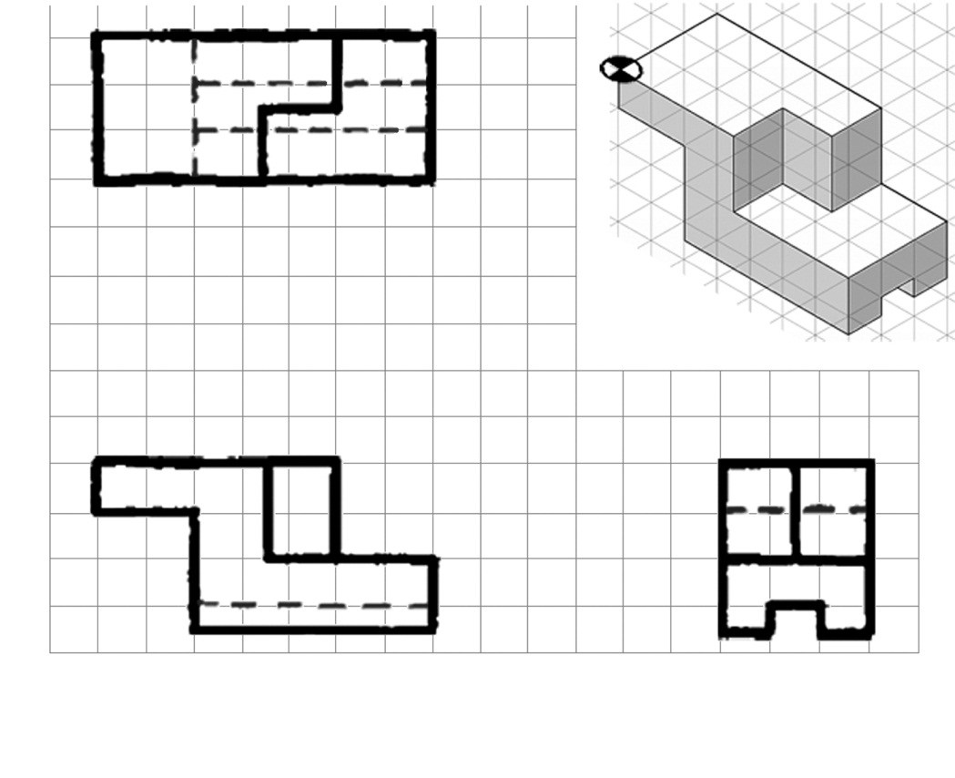
3.50
1.00
3.00
2.00
3.50
1.50
3.50
7.00

- In your notebook, create a fully dimensioned multi-view drawing for the following puzzle cube piece. Assume that the puzzle cube piece is made up of six ¾ in. cubes.
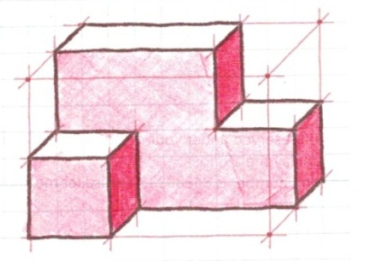
What type of pictorial is used above to represent the puzzle cube piece? How can you tell?

Front, because it shows the most detail.

- Review another student’s fully dimensioned multi-view drawing completed for number 8 above. Identify any dimensioning errors (or errors in line work, view selection, or view orientation) and record the errors on a copy of the drawing or on a separate sheet of paper. Be sure to fully describe the error and cite the Dimensioning Guideline that was misapplied.
- Fully dimension the multi-view drawing of the Automoblox Passenger Section below using the measurements you recorded Activity 3.3 Making Linear Measurements. We will discuss tolerances later, but for now assume that the part must be dimensioned to the thousandth of an inch in order to insure sufficient dimensional accuracy.
Note that the right view is a section and shows the holes using solid object lines instead of dashed hidden lines. This view is drawn as if the part was cut in half (at the D-D line in the front view) and you are looking at the cut surface. The hatched area indicates solid material. You will learn how to create section views later. For now, use the section view to dimension the depth of the holes. Connector inserts must fit into the holes in the part. 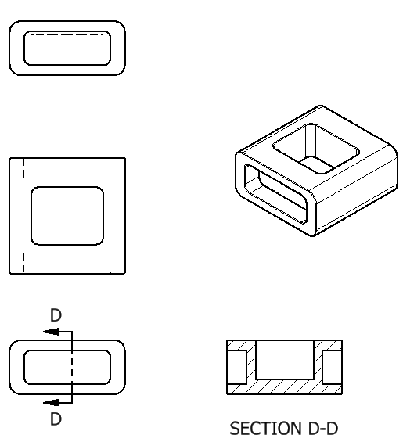
Extend Your Learning
- In your notebook create a fully dimensioned multi-view drawing for the part shown below. Note that you have already sketched orthographic projections in Activity 2.4 Multi-view Sketching.
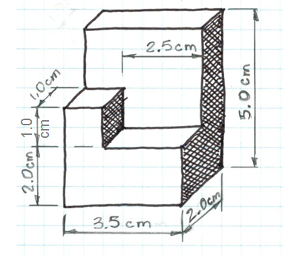
- Go back to Activity 2.4 Multi-view Sketching. Fully dimension the multi-view sketches that you created in numbers 3 through 5. Use the following grid spacing.
- For numbers 3 the grid line spacing is 0.5 cm.
- For number 4 the grid line spacing is 2 mm.
- For number 5, the grid line spacing is 0.25 in.

- In your engineering notebook, create front, top and side orthographic projections of the connector socket that is inserted and affixed to the passenger section or the front section of your Automoblox vehicle. Typically a product would be completely disassembled in order to obtain true dimensions; however, we do not want to damage the Automoblox vehicle. Therefore, as carefully as possible, without damaging the vehicle, establish all necessary measurements and dimension your drawing accordingly. You may reproduce the section view below in lieu of the right view. Assume that the square (or triangular, or oval, etc.) are solid plastic but that the wall thickness of the plastic is .05 inches as shown in the section view below. Remember, a section view is drawn as if the part were cut in two (at the A-A line in the front view) and you are looking at the cut surface. The hatched area indicates solid material. You will learn how to create section views later.
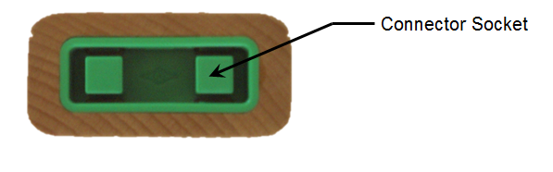

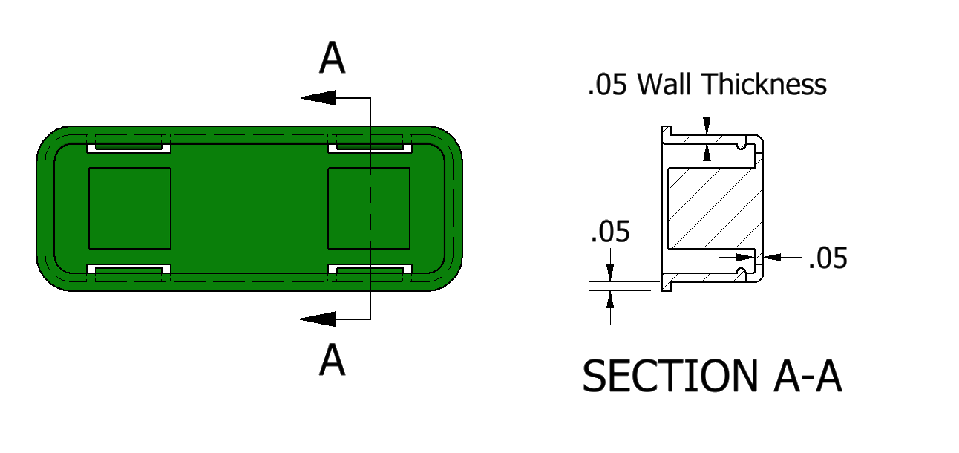
Conclusion
- Why is placement of your dimensions so important?

- Why do designers need to fully dimension a part?

- What does it mean when a sketch is over dimensioned?

